

Name:-Heena Kausar Mulla.
She has 2 years of experience as Maths Teacher at Kilbil High School and a 3.5 years as Project Engineer in Wipro Technologies.
She has done her B.Ed, BCA, PGDM C-Dac.
Additional Courses:- Java, C, C++, IBM Info sphere boot Camp.
___________________________________________________________________________
A Tech Master Trainers’ Program (2018 -2019)

5E Lesson Plan
General Information
1. Name of the school: Kilbil High School and Jr. College, Pune.
2. Name of the teacher: Heena Kausar Mulla
3. Date: 17-12-2018
4. Subject: Mathematics
5. Grade: 5
6. Topic: Circle
7. Unit: Shape, Components, Radius, Diameter and Construction.

Mathematics lesson Objective:-
After the lesson, the student will be able to:
1. Recognize shape of circle.
2. Recall components of circle. (Center of circle, Radius, Diameter, Chord).
3. Construct circle with given any measurement.
4. Differentiate relationship between radius and diameter.
5. Measure diameter and radius of Circle.
6. Revise components of circle.
7. Formulate and find diameter or radius by given requirement.
8. Design circle by using correct geometrical instrument.

Vocabulary:-
1. Industrial revolution
2. Radius
3. Diameter
4. Chord

Materials/ Resources Needed:-
1. Internet
2. Videos
3. Links
4. Notebook/ Writing Material
5. Geometrical box for Construction
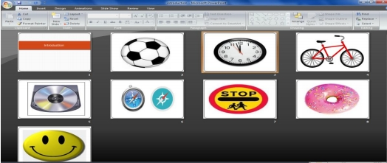A Tech Master Trainers’ Program (2018 -2019)

Period 1:-
Knowledge: Activating Strategy (Engage):-
First students will observe the pictures shown to them via a PPT presentation to understand shape of circle.

These Pictures will introduce them to the shape of circle.

Activity: - Students will see a video and answer few questions.
1. You know what circle is right?
2. Count number of circle given in picture?

Then students will able to answer the following questions after seeing the picture:-
1. What shapes did you observe?
2. Can you see similar shapes around your surrounding?
3. What all parts did you observe in video?

Method:-
Teacher will firstly show them pictures and introduce the lesson Circle.
Teacher will also explain how many things in our day to day life (as shape of circle) help us.
Teacher will also show a video and do activity to create interest and motive children towards learning circle as topic in
detailed.

Home Assignment:-
1. Write down 5 circular shaped objects that help in you personally in your daily life?

Period 2:-
Explore/ Explain:-

Once the children have learned about the shape of circle.
Teacher will show a video to observe various components of circle.
This video will take students into more in details how circle has various parts and they are said as components of circle.

Teacher will also explain all components of circle with figure by drawing figures on black board and with the help of PPT.
1. Centre of the Circle:-
A circle is a set of all points in a plane that are all an equal distance from a single point, the center.
2. Radius of the Circle:-
The line joining the centre of the circle at any point on the circle is called a Radius.

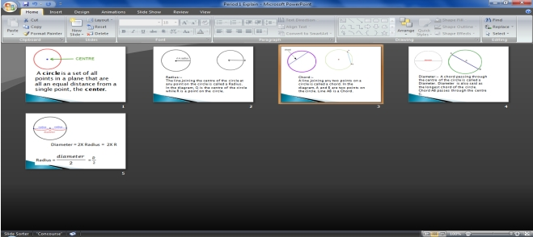A Tech Master Trainers’ Program (2018 -2019)

3. Chord:-
A line joining any two points on a circle is called a chord.
4. Diameter:-
A chord passing through the centre of the circle is called a Diameter. Diameter is also said as the longest chord
of the circle.

5. Radius = =
2 2
6. Diameter = 2X Radius = 2X R

Answer the following questions:-
1. What is a chord?
2. Which is the longest chord?
3. What is radius?
4. What is diameter?

Method:-
Now, the teacher also introduces formula of radius and diameter to students via below link.
And also gives an explanation on black board with the help of PPT presentation.

https://www.youtube.com/watch?v=SBIv5-7RbQY

https://www.youtube.com/watch?v=5K2yxm0WA58

These two videos have an explanation to the radius and diameter.
Which help student to revise the formula of diameter and radius and how it works?

Teacher also uses the below link to show a video on how to construct a circle with correct geometrical instrument.

https://www.youtube.com/watch?v=aEnhQwuGgEU

Now, teacher makes a group of 5 students to show how to use the geometrical instrument to construct circle as below
points:-

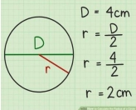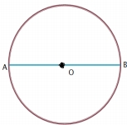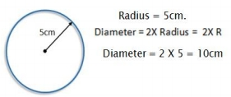1.
2.
3.
4.
A Tech Master Trainers’ Program (2018 -2019)

First fix the pencil to the compass. Align the metal tip of the compass with the pencil point.
Take a convenient distance between the pencil point and the metal tip.
Take any point on a piece of paper.
Hold the metal tip steady on the chosen point and turn the pencil point around it on the sheet of paper. This

shape created by the pencil point will be a circle.
5. To draw a circle of a given radius, a distance equal to the radius kept between the pencil point and the metal tip
of the compass by use of scale.

Period 3:-
Apply
1. At this level, children will apply the formula to find radius and diameter.

2. Children can now find radius and diameter by applying formula as per given questions.
3. Children can now also construct circle by given measurement and name it.

Activity:-
1. Teacher display various measurements on black board.
2. Teacher ask students to follow below instructions:-
a. Construct the circle with given measurement.
b. Name to the circle.
c. Find diameter.
d. Find radius.

Period 4:-
Analysis:-

In this level, children will learn able to inspect the relationship between diameter and radius, and calculate various
aspects of circle by doing below activity.

Activity 1:-

a.
b.
c.
d.
Which are the radii in the circle?
How many radii make up diameter AB.?
If the length of one radius is 3cm. what is the length of the diameter?
How long is the diameter compared to the radius?

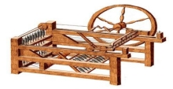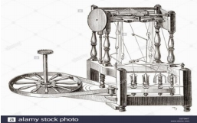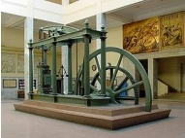A Tech Master Trainers’ Program (2018 -2019)

Activity 2:-
Teacher makes a group of 5 students and asks them to do below activity.
a. Draw a circle on a piece of paper and cut it out.
b. Name the centre of the circle P.
c. Draw the diameter of the circle and name it AB. Note that PA and PB are radii of the circle.
d. Fold the circular paper along AB.
e. Fold the paper at P in such a way that point B will fall on point A. Radius PB falls exactly on radius PA. in other
words, they coincide.
f. From this, we can see that every radius of a circle is half the length of its diameter.

Period 5:-
Synthesis:-

Children can also view below link and can explore the evolution of industrialization.
https://www.britannica.com/list/inventors-and-inventions-of-the-industrial-revolution

Children at this level will combine components of circle and construction of circle and can relate it to other sources
(industrialization) like for example:-
1. The Spinning jenny.

2. The Water Frame:-

3. The Watts Steam Engine:-

A Tech Master Trainers’ Program (2018 -2019)

Evaluation:-

In this level, children evaluate themselves by accessing below link to check if they would be able to solve the following:-

https://www.math-only-math.com/worksheet-on-circle-a.html

Students can take test MCQ’s by accessing below link:-

https://www.proprofs.com/quiz-school/story.php?title=parts--circle_2

Teacher will create group of 5 and play a game by using application kahoot.

